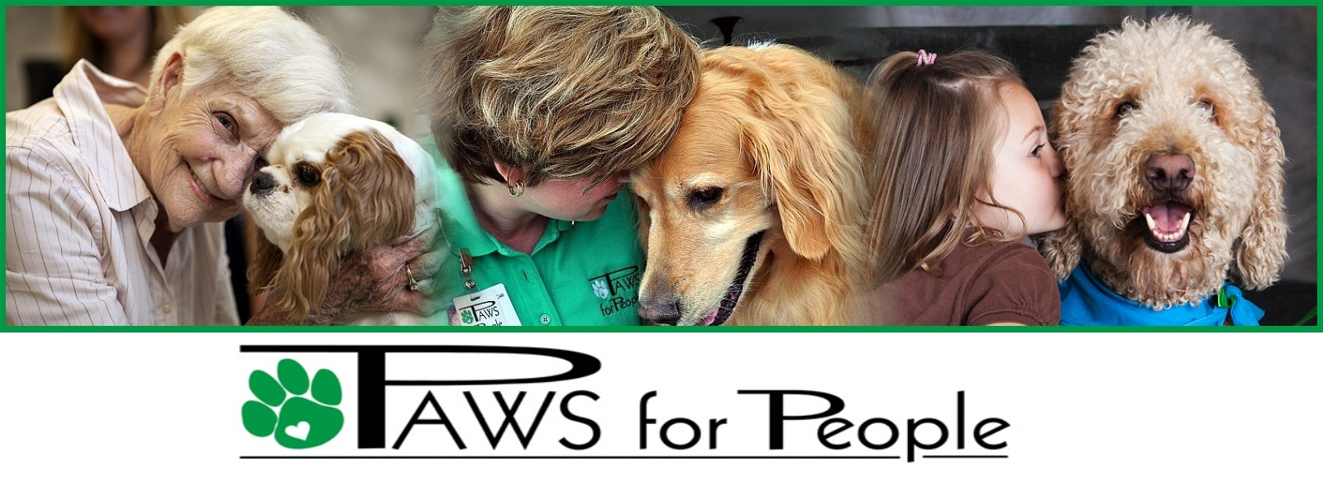
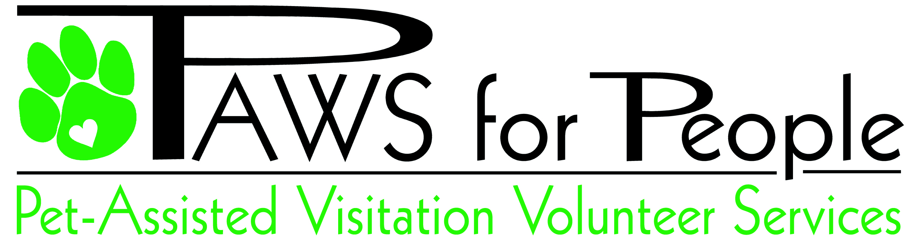

Our Mission:
To lovingly provide elders, children, and folks with disabilities individualized, therapeutic visits with a gentle, affectionate pet.
Our Vision:
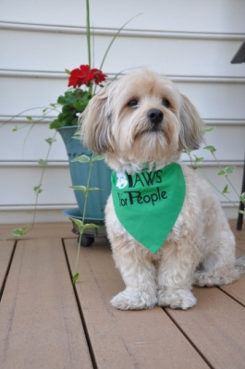
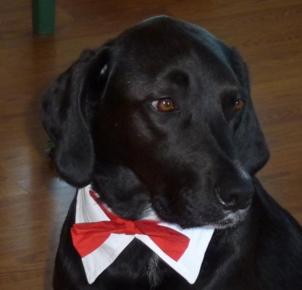
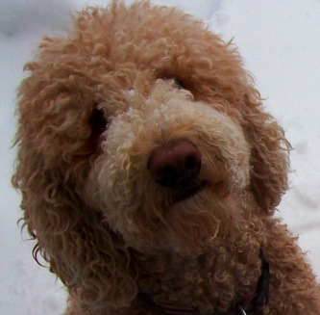
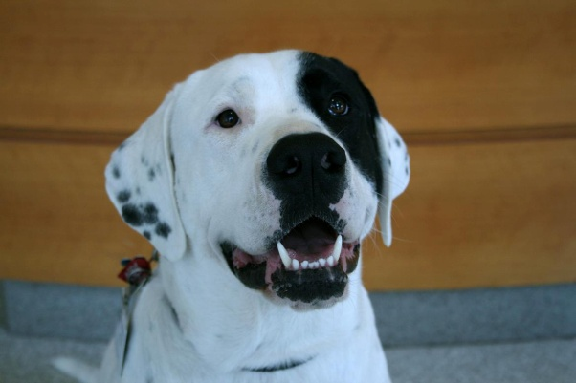
To reach greater number of people and more diverse populations through one-on-one directed visits so that people can enjoy the healing benefits of pet therapy.

Who is PAWS for People?
We are a non-profit organization with more than 350 volunteers who, with their own pet dog, cat, or rabbit, provide comfort and support for people of all ages throughout the greater Wilmington area. Volunteers are trained and certified by PAWS staff and then together determine the kind of therapy visit that will be most beneficial to both the therapy team and the client.

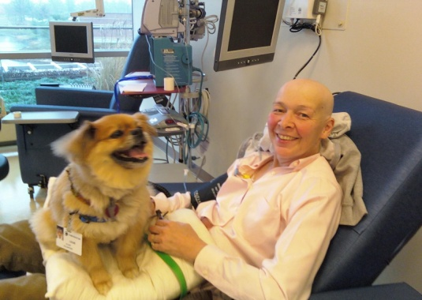
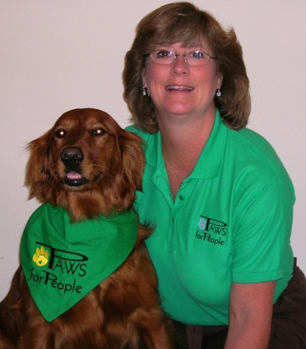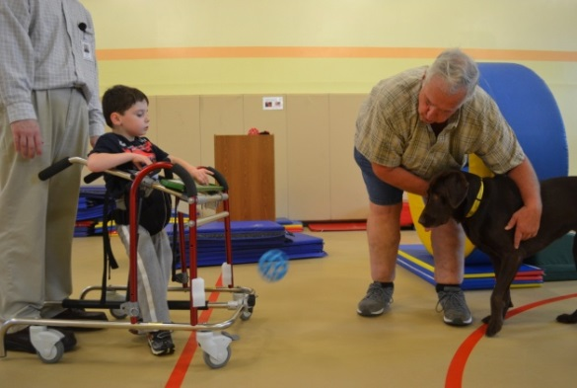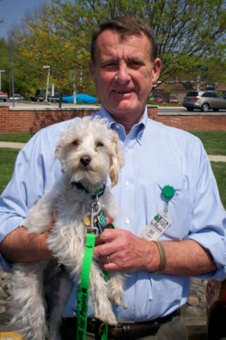
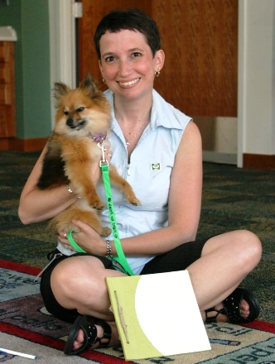
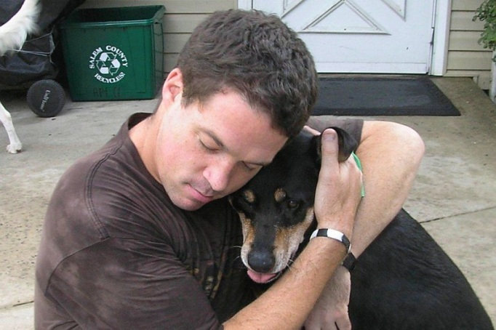
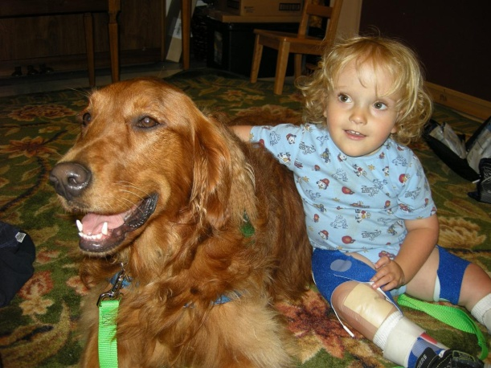
Where do PAWS volunteers go?
We provide therapy visits to anyone in need in Delaware and surrounding areas. From the delivery room to comforting those in hospice care, PAWS volunteers share their loving relationship with their own pet with people confronting personal, emotional, or physical challenges. Some of the places our volunteers go include:
- Christiana Care Hospitals
- Brandywine and Christina schools and libraries
- Helen F. Graham Cancer Center
- Union Hospital
- Assisted living facilities and nursing homes
- Drug & alcohol treatment centers
- A.I. du Pont Hospital for Children
- Sussex County, DE
- Cecil County, MD schools & libraries
- OT/PT facilities
- Cecil County Department of Social Services including Cecil County Circuit Court

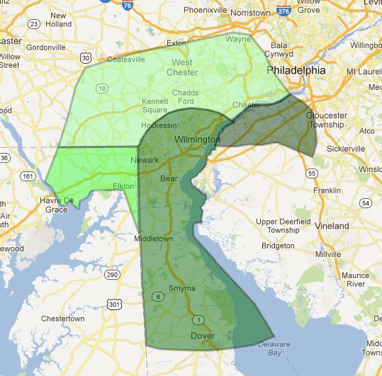

Where do PAWS volunteers go?

PAWS in 2013

- 14,000 hours volunteered by PAWS for People members
- 140 sites receive visits from PAWS teams
- Current membership is 400+
- 102 training sessions conducted for volunteers
- 100+ community outreach events attended by PAWS in Delaware, Pennsylvania, Maryland, and New Jersey
- 30 public relations events including interviews, tv, radio, newspaper
- 196 first visits took place throughout the four state area
- 54 teams were certified at the Advanced Training level

What Our Community Says About PAWS
“I praise PAWS for People for being the leader in our area of recognizing the medical benefits of animal-assisted therapy and to providing it for our community. PAWS has established a program for training and certifying their therapy teams which is superior. Further, they have researched and learned how best to train their teams so that they can be most help to the medical community. “ Michele D. Cavanaugh, MS, APRN Psychiatric Nurse Specialist
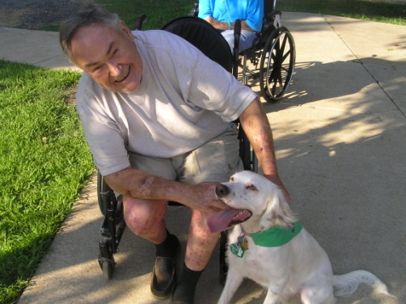
“PAWS for People has been providing animal-assisted therapy visits to Chimes Delaware for more than 2 years. The program benefits people of all levels of ability. We have seen reclusive people engage with the dogs. Some people hug the dogs, some play with the dogs, and some talk to them and most are excited and anticipate the visits. There is a definite positive effect that we don’t often see from other types of activities.”
Pete Dakunchak, COO Chimes, DE

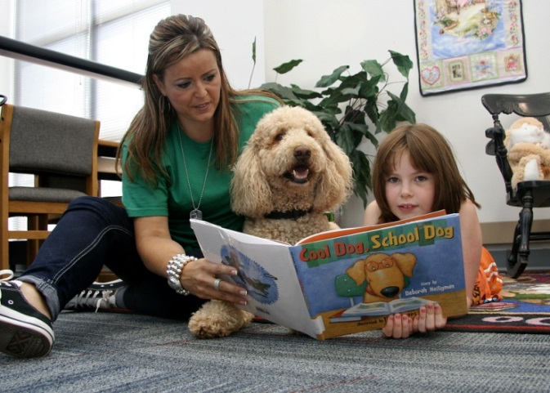
”The PAWS for Reading program and the quiet acceptance of its therapy dogs has proven to be a remarkable motivator for children’s interest in reading, encouraging them to become more self-confident about reading. Confident readers read more. Children who read more develop better vocabulary and comprehension skills, which are two extremely critical goals for any reading program.”
Dr. Jim Scanlon, Superintendent, West Chester Area School District

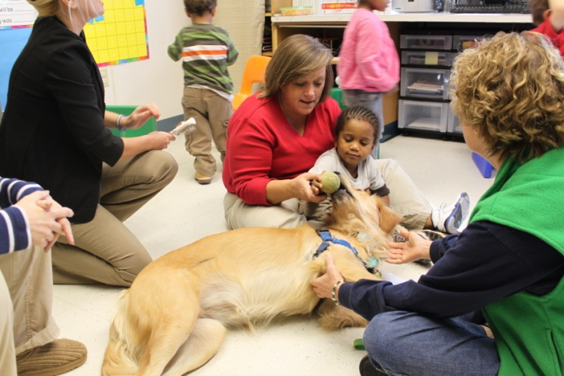
“PAWS therapy teams – consisting of a person and his or her dog- works with educators and parents to help children with autism spectrum disorders meet their individualized education plan goals. We use the dogs as a motivational bridge and the children practice some skills and don’t worry about making a mistake. It’s a motivator. Teachers see improvement in students’ verbal and communication skills since the PAWS initiative began.” Autism Delaware newsletter, The Sun

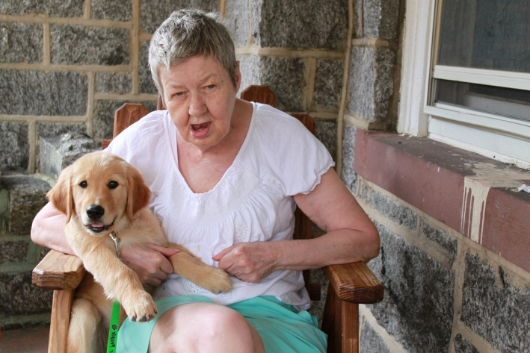
”The companionship that our consumers receive from the dogs put
them in the highest spirits and they look forward to each and
every visit. This program has benefited people with all levels of
abilities. Our staff can see the affect it has on each individual as
the visits bring reclusive people out of their shell to seek
affection or to pet the dogs. There are no real words to describe
the satisfaction we see on their faces. They are relaxed and
elated all at once. Working in a field where we often rely on
alternative methods of communication I can say with certainty
that the message is clear on the faces of those participating in
this wonderful program.” Jennifer Tozer-Halloran, Easter Seals

Working with Our Community
Support from the people and businesses who benefit from, and appreciate the value of, PAWS’ programs is vital to our ability to help those in need. More than 75% of our funding comes from donations. Our strong volunteer and donor base are the foundation on which all of PAWS’ efforts are made possible.
Medical professionals and educators understand the benefits of animal-assisted therapy and our supporters recognize the value of working with PAWS to support its efforts. Partnerships between PAWS and local businesses are offered at many levels.
We have the ability to tailor partnerships to meet the specific areas of importance of our supporters. Programs which can receive targeted support include
- Autism
- Cancer
- Hospice
- Reading
- Mental Wellness
- Drug & Alcohol Rehabilitation
- Physical & Occupational Therapy

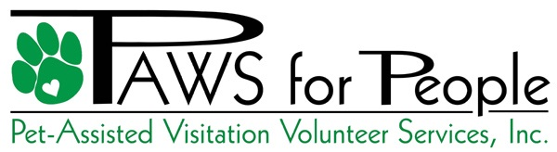

PO Box 9955
Newark, DE 19714
Tax ID # 76-0780197

Phone 302-351-5622 Fax 302-351-8116
www.PAWSforpeople.org

Board of Directors
Cathy G. Amick, Vice Pres., PAWS for People
Luann D'Agostino - owner/ director, Take the Lead Dance Studio
Karen Bengston, Nemours/AI du Pont Hospital for Children
Stan Diver, Diver & Associates, LLC
Jeanne Kasey, Public Relations Manager, Big Brothers Big Sisters
Margi Prueitt, Executive Director, Produce Marketing Association (PMA) Foundation
Robert Reardon, financial consultant; Chairman, Sporting Goods Properties
Lynne Robinson, Executive Director, PAWS for People
Samantha Romich, Legal, Incyte Corporation
Paul Rosen, M.D., Clinical Director of Service Excellence, Nemours/AI du Pont Hospital for Children
William H. Sudell, Jr. , Esq., Morris, Nichols, Arsht & Tunnell, LLP, retired
Susan D. Trolio, Santora CPA Group
LeDee Wakefield, The Inn at Montchanin

